**MBEUR Sales ETL Failed Run Book**

|  |  |
| --- | --- |
| Created By: | Sivaprasad |
| Created On: | July 7th 2018 |
| Version: | V0.1 |

**Scheduling**

The MB_EURruns on the following schedule (US Central Time):

|  |  |
| --- | --- |
| **START_TIME** | **EXPECTED END_TIME** |
| 10:00 PM | 12:15 AM |

**User Communication**

Please check BISupport mails in MB_EUR folder and sub folder Tempalte check with subject line

**“BUSINESS NOTIFICATION: Delay in Delivery of MBUK Tracking Performance”**

**General Information**

Main Policy Name: ETL: Sales With R Tables

Main Policy location: RHPOISM1\RHPOIS09\MB\MB Europe

SSIS Batch 1: C:\SSIS\EDW\INVENTORY_ANALYTICS_MASTER_MB_EUR.bat

Batch file runs in server RHPBIETL3.

Logs:

D:\SSIS\WAREHOUSE_PICKER\LOG

We are getting failure mails like below:

**(ITSC ACTION REQUIRED) FAILED: MBEUR Sales ETL**

**Package Failure: Inventory_Analytics_Master_MB_EUR**

**Package Failure: F_INVOICE_LINE_DTL**

**Error:**

Description: "Cannot insert duplicate key row in object 'dbo.F_INVOICE_LINE_DTL' with unique index 'XPKF_INVOICE_LINE_SNAPSHOT'. The duplicate key value is (MB_EUR, 0*4007949*SO, 307000, 0, 2967180, 111).".

**ISSUE#1 No failure emails but the job has not completed on time**

1. Check the Opalis policy to see if the job is running and what is running.
2. If the policy is not running, then look at issue#2 on how to troubleshoot

**ISSUE#2 MBEUR Sales ETL (Inventory_Analytics_Master_MB_EUR) failed due to duplicate issue**

Error Description: F_INVOICE_LINE_DTL Failed at task: Data Flow Task - F_INVOICE_LINE_DTL_MB_EUR.  Error Message: SSIS Error Code DTS_E_OLEDBERROR.  An OLE DB error has occurred. Error code: 0x80004005.  
An OLE DB record is available.  Source: "Microsoft SQL Server Native Client 10.0"  Hresult: 0x80004005  Description: "The statement has been terminated.".  
An OLE DB record is available.  Source: "Microsoft SQL Server Native Client 10.0"  Hresult: 0x80004005  Description: "Cannot insert duplicate key row in object 'dbo.F_INVOICE_LINE_DTL' with unique index 'XPKF_INVOICE_LINE_SNAPSHOT'. The duplicate key value is (MB_EUR, 0*4007949*SO, 307000, 0, 2967180, 111).".

IF package **Inventory_Analytics_Master_MB_EUR** failed due to duplicate issue as mentioned as above to find the duplicates in Fact perform the below steps.

Step 1: First find out the where it was failed check master package and investigate the issue like which source table having duplicate records.

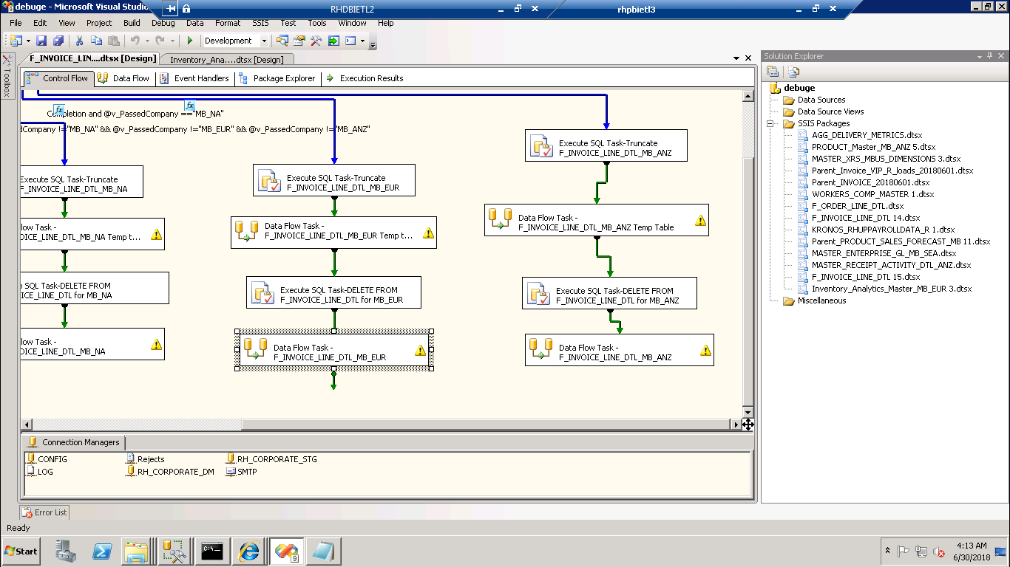

**Found the duplicate records based on error message:**

SELECT  [SOURCE_ID] ,

      [INVOICE_LINE_NUMBER] ,

      [INVOICE_DATE_SID] ,

      [CUSTOMER_SID] ,

      [DISTRIBUTION_CENTER_SID],COUNT(*)  FROM F_INVOICE_LINE_DTL_MB_EUR GROUP BY

[SOURCE_ID] ,

      [INVOICE_NUMBER] ,

      [INVOICE_LINE_NUMBER] ,

      [INVOICE_DATE_SID] ,

      [CUSTOMER_SID] ,

      [DISTRIBUTION_CENTER_SID] HAVING COUNT(*)>1

      SELECT * FROM F_INVOICE_LINE_DTL WITH(NOLOCK)WHERE [SOURCE_ID]='MB_EUR' AND

      [INVOICE_NUMBER]='0*1000567*SR' AND

      [INVOICE_LINE_NUMBER]='3000' AND

      [INVOICE_DATE_SID]= 0 AND

      [CUSTOMER_SID]=1149666 AND

      [DISTRIBUTION_CENTER_SID]=111

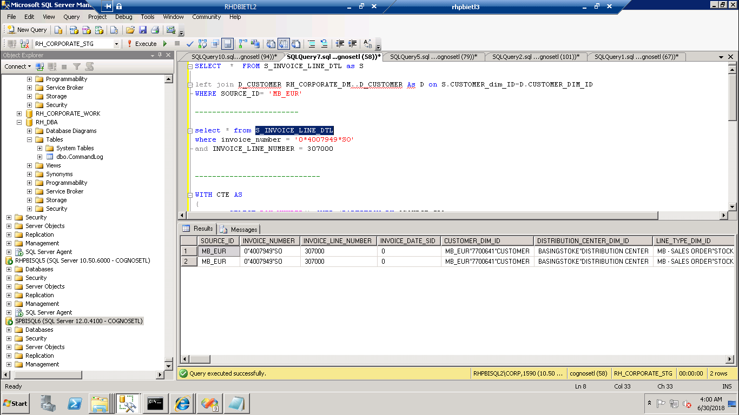

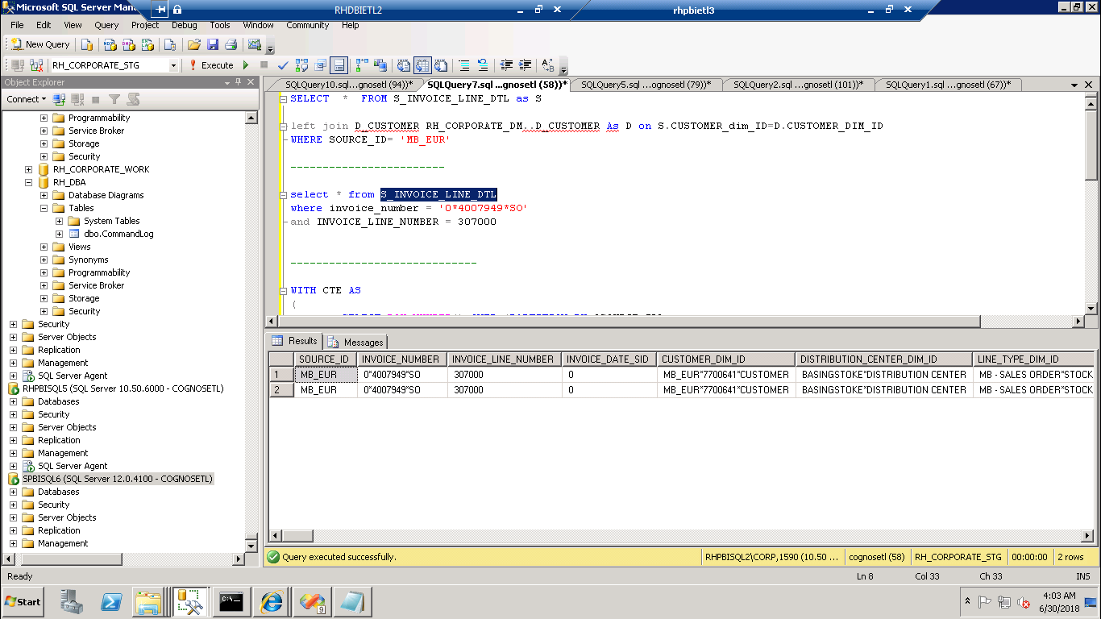

**Step2:**

Take the backup of the table

Select * into F_INVOICE_LINE_DTL_MB_EUR_07-07-2018 form F_INVOICE_LINE_DTL_MB_EUR

Step3:

**Delete Duplicate records command:**

-- begin tran

with cte as (

SELECT

 [SOURCE_ID] ,

      [INVOICE_NUMBER] ,

      [INVOICE_LINE_NUMBER] ,

      [INVOICE_DATE_SID] ,

      [CUSTOMER_SID] ,

      [DISTRIBUTION_CENTER_SID],

  ROW_NUMBER() OVER (PARTITION BY [SOURCE_ID] ,

      [INVOICE_NUMBER] ,

      [INVOICE_LINE_NUMBER] ,

      [INVOICE_DATE_SID] ,

      [CUSTOMER_SID] ,

      [DISTRIBUTION_CENTER_SID] ORDER BY [SOURCE_ID] ,

      [INVOICE_NUMBER] ,

      [INVOICE_LINE_NUMBER] ,

      [INVOICE_DATE_SID] ,

      [CUSTOMER_SID] ,

      [DISTRIBUTION_CENTER_SID]) AS Row FROM dbo.F_INVOICE_LINE_DTL_MB_EUR

      ) select * from cte where row  >1

      commit

      SELECT  [SOURCE_ID] ,

      [INVOICE_LINE_NUMBER] ,

      [INVOICE_DATE_SID] ,

      [CUSTOMER_SID] ,

      [DISTRIBUTION_CENTER_SID],COUNT(*)  FROM F_INVOICE_LINE_DTL_MB_EUR GROUP BY

[SOURCE_ID] ,

      [INVOICE_NUMBER] ,

      [INVOICE_LINE_NUMBER] ,

      [INVOICE_DATE_SID] ,

      [CUSTOMER_SID] ,

      [DISTRIBUTION_CENTER_SID] HAVING COUNT(*)>1

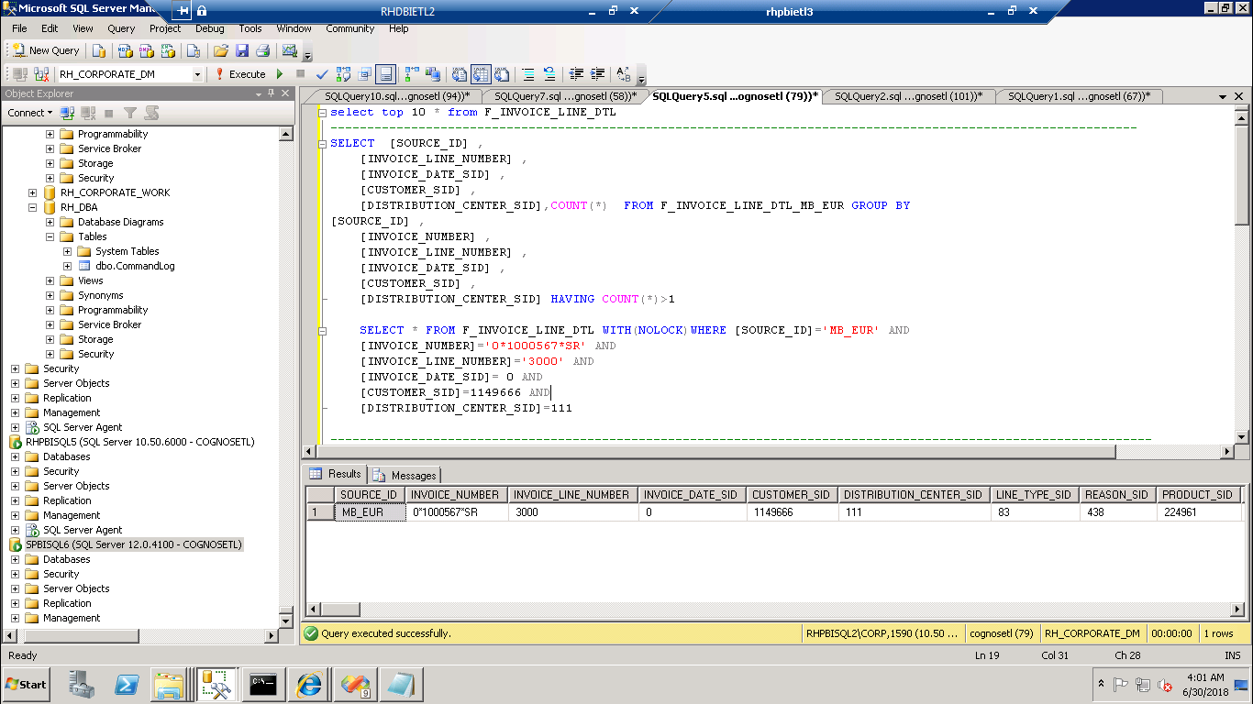

Confirm to check duplicate records only deleted or not.

**Step4:**

Need to run the package if above SQL task is there first you need to run that task then execute the next task.

No need to run entire package run which one was failed right click execute the task.

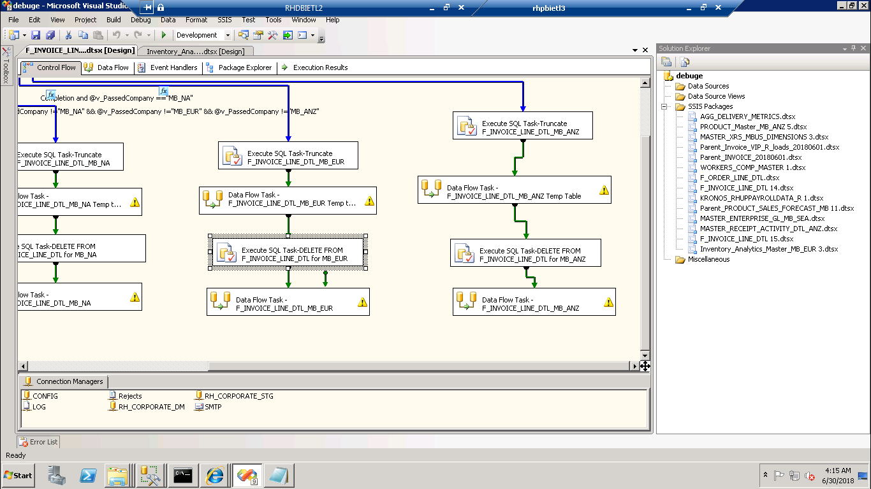



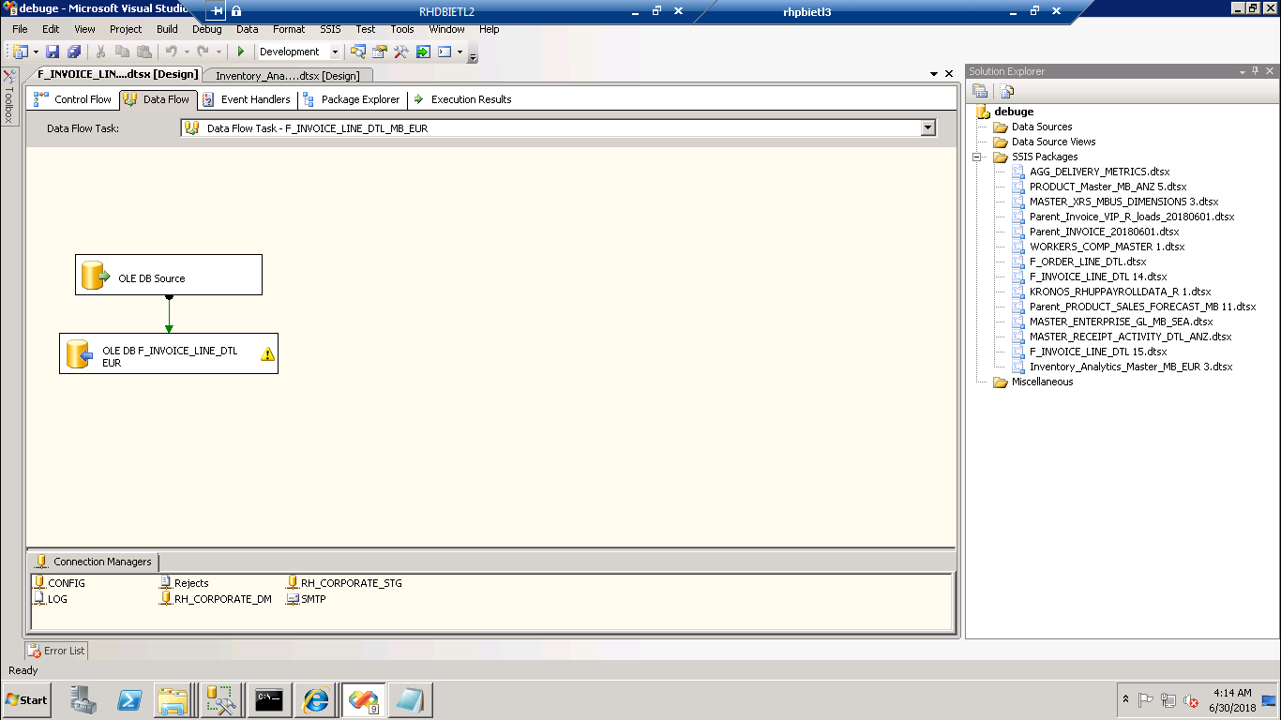

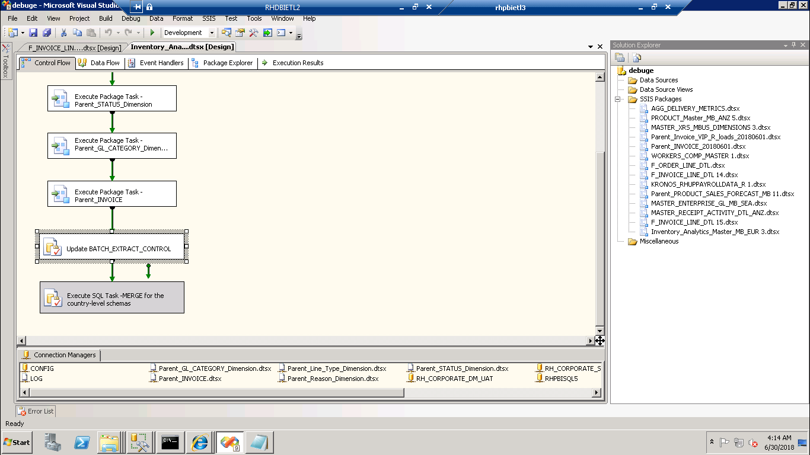

Check master package and run the remaining packages if it is there.

**Step5:**

Once package completed successfully we have to follow the Excel Document :

**MBUK Sales Manual Loading v3**

And completed the all the steps.